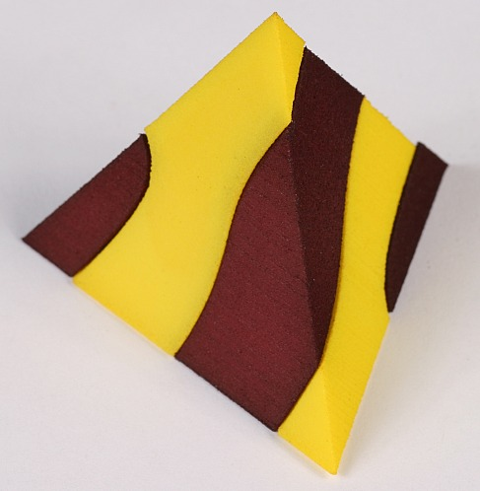 | FIRE  George W. Hart  Dept. Computer Science  Stony Brook University  http://www.georgehart.com | 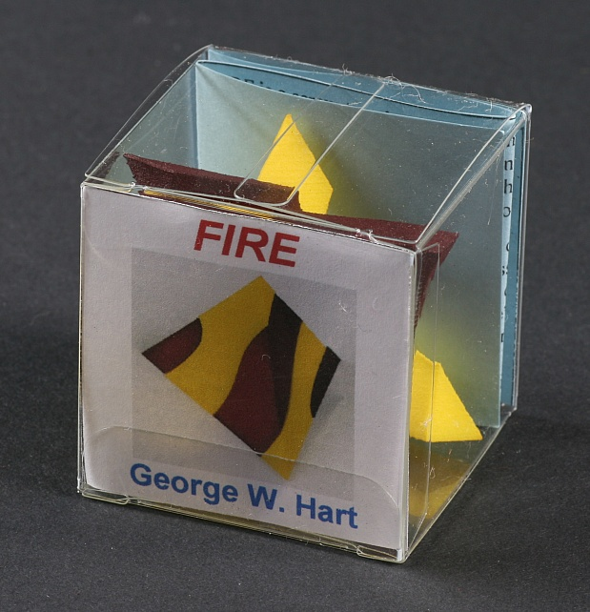

FIRE is a screw-together tetrahedron made of two identical nylon parts, one dyed red and one dyed yellow. The name is taken from Plato’s proto-chemistry mysticism, in which the tetrahedron represents the classical element of fire. The polyhedron is split along a helicoid surface whose axis is aligned with a two-fold axis, i.e. passing from one edge midpoint to the opposite edge midpoint. This helicoid makes 1.25 revolutions between these edges.

Assembling the halves is challenging because we are not accustomed to screws that do not look like nuts and bolts. The key to its assembly is to start by positioning the two pieces symmetrically as shown below. From this state, there is a smooth screwing motion which brings the parts together. The computer rendering shows another view of the form.

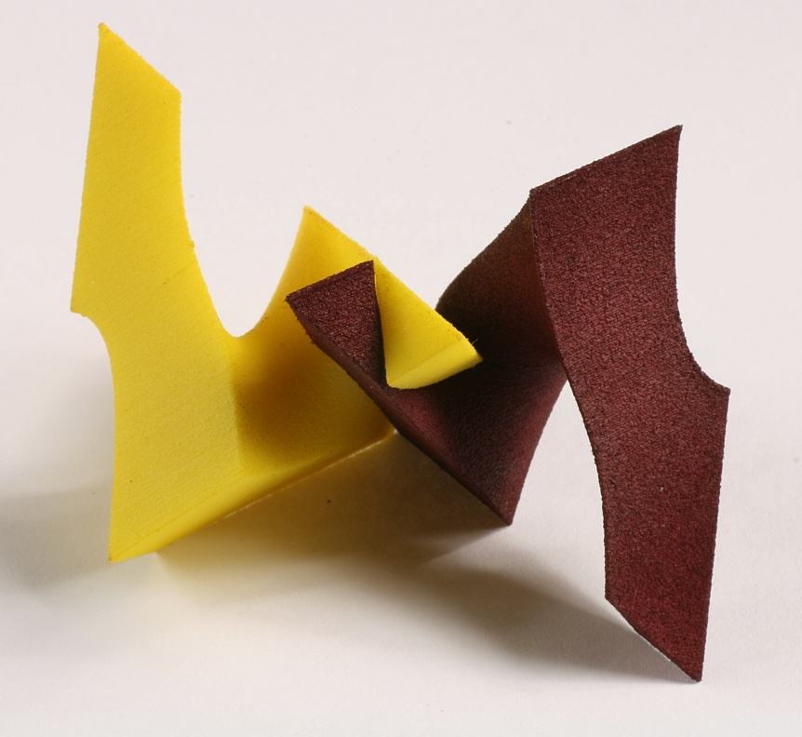 | 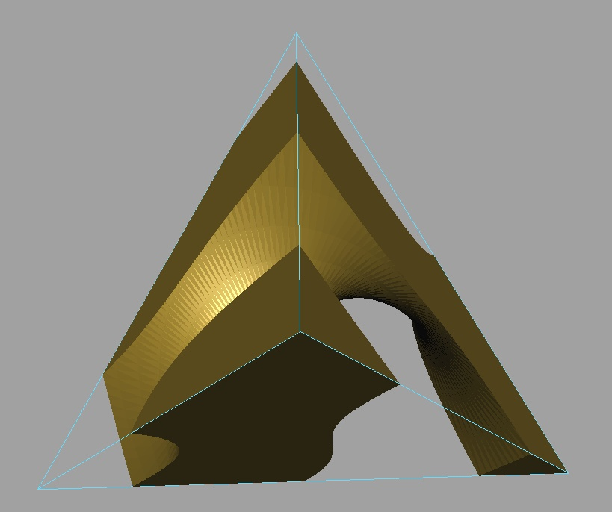

This is one instance within a family of related screw dissections that others have also explored. Martin Gardner credits a related three-piece cube dissection to John E. Morse. [The Magic Numbers of Dr. Matrix, Prometheus Books, 1985, p. 319] William Huff describes related forms used as exercises in an architectural design class. [William Huff, “Trisecting the Cube”] A three-piece screw-together cube designed by Robert Reid in the 1980s and recently realized by Oscar van Deventer and George Miller is commercially available at www.puzzlepalace.com. I came to appreciate the elegance of this family of forms after seeing a two-piece screw-together tetrahedron (with a different screw pitch) that Rinus Roelofs designed and brought to the 2005 Bridges Conference [www.bridgesmathart.org].

