Name: Doug Burkholder
Affiliation: Lenoir-Rhyne College
Title of Summary: Non-Planar Polygon Sculptures
Type of Audience: HS, College, Math or Art
Relevant Fields: Linear Algebra, Geometry, Art

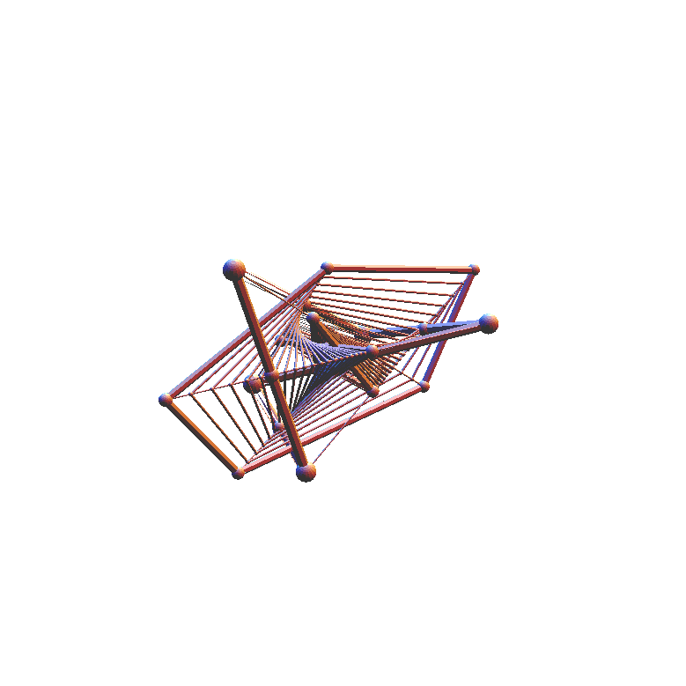
If the five vertices of any irregular non-planar pentagon each slide down their respective median line at speeds proportional to the length of the lines, then at a certain moment in time, these five points have folded themselves up and flattened out to form a stellar planar affine regular pentagon. As these points continue sliding, they unfold, and flatten out once again to form a non-stellar planar affine regular pentagon. With the exception of a few degenerate cases, affine regular polygons appear regular when viewed from a certain direction. A sculpture, shown to the right, visually shows this transformation of random non-planar polygons into planar affine regular polygons.
p₅
p₄
p₁
p₂
p₃

.
w₂ = 1
w₁ = 1
w₄ = σ
w₃ = 0
w₅ = 0
It turns out to be surprisingly easy to create a mathematical formula which can be used to construct a sequence of steps which planarizes a polygon of any degree to produce the affine image of any regular and perhaps most irregular polygons. For example, the figure to right determines the location of the planar stellar affine regular pentagon in the sculpture above. Both math students and artist can explore alternate possibilities.

We can do a similar, but different procedure for hexagons. Starting from any random hexagon, you construct six new points 1/3 of the way from the midpoint of each side to the midpoint of the corresponding diagonal. One of the six new points is shown in the figure to the left. Both artist and mathematicians can play around with the unexpected result. In a linear algebra course, students can form conjectures and use linear algebra to verify their results.

